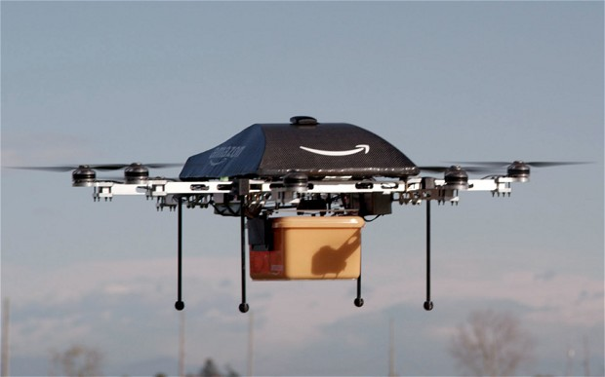

Your team has been chosen to develop a simulator to train pilots to fly the Amazon Delivery Vehicle (ADV). The ADV is deployed from a nearby-launch pad/warehouse where the package is attached and then sent out for delivery. The ADV is un-manned - the ADV Simulator will simulate the last two minutes of flight - this is the point where it stops following the airborne delivery corridor and egresses to the delivery location. This portion of the ADV does not simulate pilot steering controls - it trains the pilot on alerts and warning before the next step in the simulation. Project requirements follow.

The ADV shown in the picture above has a retractable shield around the package to allow for fast delivery speeds. The picture shows the drone with the package shield retracted - getting ready to deliver a package. The following depicts a typical delivery drone flight.



The ADV has a single display on the pilot's PC. This display has three kinds of alerts - alarms, warnings, and indicators. All alerts are white/clear when not active. Alarms are enabled when the pilot is required to take some precautionary action, warnings are enabled when the system has taken some action the pilot should be informed about, lastly indicators are used to inform the pilot that an optimal condition has been reached. Alarms are red when enabled, warnings yellow, and indictors green. Warnings, when enabled, stay lit for 5 seconds to ensure that the pilot/operator has acknowledged the condition. There are no audible alerts.

In addition to the alerts, the display also shows the following information: altitude (feet), velocity (feet/second), motor program (see table 1), package shield position, package shield switch (up or down), package shield command (see below), power remaining (Watts) and attitude (+/- degrees). The simulator will use the equations depicted in Table 1 to calculate altitude and the two velocities Vf (the forward velocity) and Vd (the downward velocity). power consumed is calculated using the retrorocket rates from table 1 and using the following equations.

alt(t+1) = alt(t) + alt rate (alt rate from Table 1)

Vd(t+1) = Vd(t) + VdRate (VdRate from Table 1)

Vf(t) = 15.0 * abs(Vd(t))

The simulation starts with an initial altitude of 225 feet (x) , an initial velocity (Vd) of -6.8182 miles/hour, and 300 watts of power for the four engines.

Table 1



As described in table 1 the motor program has 4 modes - 2 flying mode speeds and off when the four engines when the altitude is <0.1 feet. The modes shown in table 1 are displayed on the cockpit display.

Table 2 depicts the cockpit alerts and switch.

Table 2



ADV control is almost entirely controlled by the software. The primary pilot inputs are to retract the shield (see table 2) and to adjust attitude. The former is controlled by the Shield Position button (Retract/Deploy) on the display as described by table 2. The latter is controlled by the engines which are activated by depressing the ">" (+1 degree) and "<" (-1 degree).

When the simulation begins, Amazon sends the delivery site terrain attitude and the pilot must adjust the attitude as described in table 2 to successfully land. Both the terrain attitude and the ADV attitude must be displayed. Once the ESR is signaled and the shield retracted, the pilot is unable to subsequently deployed the shield regardless of the button setting. When the ESR is issued - the button position is updated accordingly.

The simulation calculates altitude, velocity, attitude and power remaining, updates all alerts based on these calculations and displays data as described earlier - all once per second. This is accomplished by using the Java Sleep to update once per second. The terrain attitude is determined as a random integer ranging from (-10 to +10) degrees initially at simulation start.

The simulation must be developed in Java using the Eclipse environment. We will learn Java GUI development using Window Builder, JUnit and JaCoCo (code coverage) this semester to help develop the project.

**Grading**

Part 1 - 15 % of grade (initial display layout in PowerPoint, capture of requirements and altitude/velocity calculations, and analysis of requirements)

Part 2 - 20% of grade (identify unique input combinations for the displays, and depict these display combinations in PowerPoint)

Part 3 - 20% of grade (deliver a working prototype of the simulator as a JAR file)

Part 4 - 25% of grade (develop the test cases required to stimulate the display combinations, test boundary conditions, and all other functions. Develop the code needed to read the test cases developed in class.)

Part 5 - 20% of grade (presentation - demonstrate the working code, sell-off of product)